A DATA SCIENCE REPORT
WRITTEN BY
BASSEY FAITH BASSEY-ITA
TRACK NO: 22/132039
DEPARTMENT OF MATHEMATICS AND COMPUTER SCIENCE
FACULTY OF NATURAL AND APPLIED SCIENCES
SUBMITTED TO

THE COURSE LECTURER
DR SYLVIA OLADIMEJI
DEPARTMENT OF MATHEMATICS AND COMPUTER SCIENCE
FACULTY OF NATURAL AND APPLIED SCIENCES

IN PARTIAL FULFILLMENT OF THE COURSE REQUIREMENT
SPECIAL TOPICS IN COMPUTER SCIENCE
(CSC 4)

JANUARY 2026
Facebook Stock Data Analysis Project Report

1. Overview
This project focuses on analyzing the historical stock performance of Facebook (now Meta Platforms Inc.) using real-world financial datasets. The main objective is to clean, explore, and visualize the data in order to understand trends, patterns, and key insights related to Facebook’s stock prices and trading activities. Python and Jupyter Notebook were used as the main tools for data analysis. Libraries such as Pandas and Matplotlib were applied for data manipulation and visualization.

2. Data Used
Two datasets were used for this project:
1)FB_stock_history.csv
This dataset contains historical stock information such as:
Date
Opening Price
Closing Price
Highest Price
Lowest Price
Trading Volume
2)FB_stock_info.csv
This dataset provides general information about Facebook’s stock, such as:
Company details
Stock symbol
Market-related information
These datasets were imported into the Jupyter Notebook using the Pandas library for analysis.

3. Data Cleaning
Data cleaning was carried out to improve the quality and reliability of the datasets. The following steps were performed:
Checked for missing values in both datasets.
Converted the date column to a proper datetime format for easy analysis.
Removed duplicate records to avoid repeated data.
Filled missing values using the forward-fill method.
Ensured that all columns had appropriate data types.
These steps helped to prepare the data for accurate exploration and visualization.

4. Data Exploration
After cleaning, exploratory data analysis was conducted to understand the structure and characteristics of the datasets.
The following methods were used:
Displayed the first few rows to understand the data format.
Used .info() to check column types and data completeness.
Generated descriptive statistics such as mean, minimum, maximum, and standard deviation.
Examined correlations between numerical variables.
Through exploration, important information such as average closing price, highest and lowest prices, and average trading volume was identified.

5. Data Visualization
Several visualizations were created to present the data clearly and identify trends.

a) Closing Price Over Time
A line chart was used to show how Facebook’s stock closing price changed over time. This helped in understanding long-term growth and fluctuations.
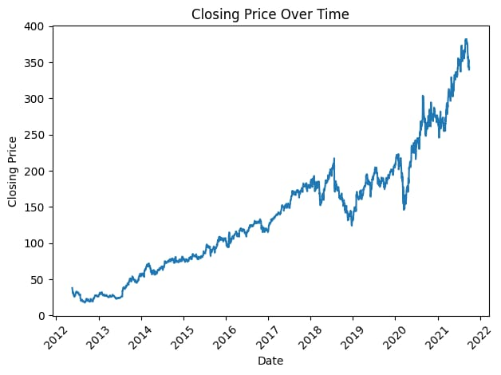

b) Trading Volume Over Time
Another line chart displayed daily trading volumes. This visualization helped to observe periods of high and low market activity.
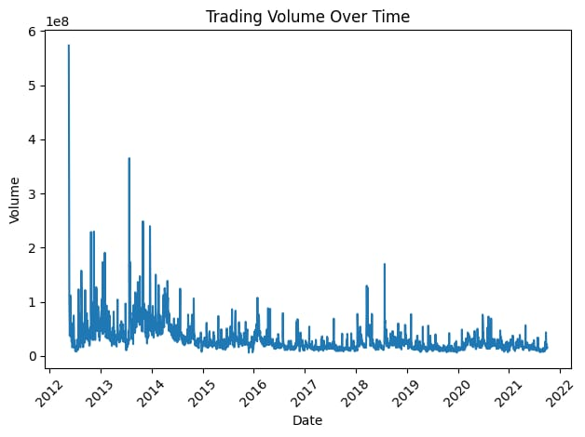

c) High vs Low Prices
A scatter plot was created to compare daily high and low prices. This showed the relationship between price ranges.
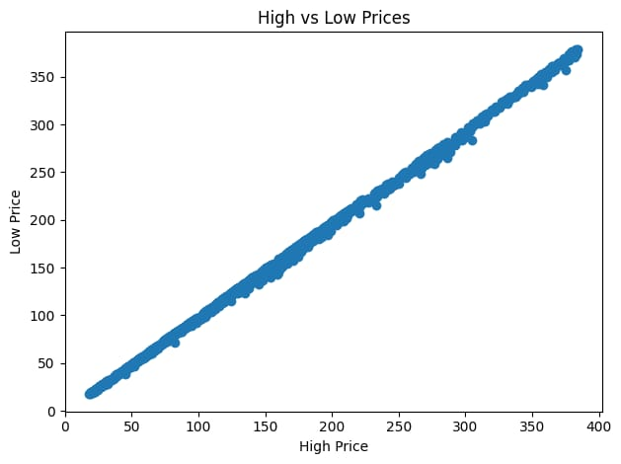

d) Distribution of Closing Prices
A histogram was used to display the frequency of different closing prices. This helped in understanding how prices were distributed.
These visualizations made it easier to interpret patterns and trends in the stock data.
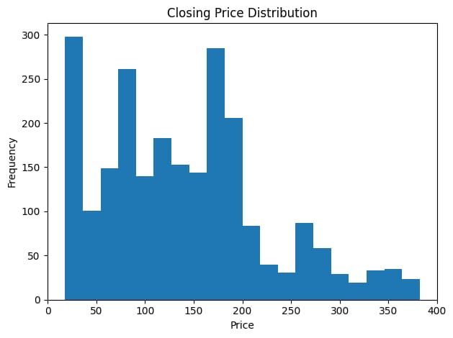

6. Conclusion
This project successfully analyzed Facebook’s stock performance using Python and Jupyter Notebook. The data was cleaned, explored, and visualized to gain meaningful insights.
From the analysis, it was observed that:
Facebook’s stock price shows significant variation over time.
Trading volume fluctuates based on market conditions.
There is a strong relationship between daily high and low prices.
Most closing prices fall within certain ranges.
Overall, the project demonstrates how data analysis and visualization can be used to understand financial trends and support better decision-making. The skills applied in this project are useful in real-world data science and financial analysis.

